**Source Page – Year 8 HASS – Assessment One**

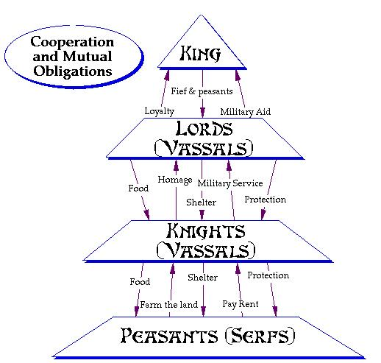

**Source One**

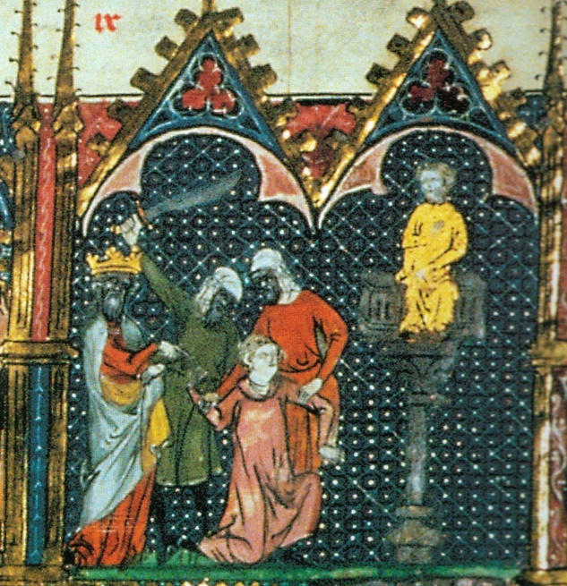

Crusade propaganda: Christian pilgrims killed by Muslims in the Holy Land, manuscript illustration, circa, 1096

**Source Two**

*"Undertake this journey for the remission of your sins,   
with the assurance of the imperishable glory of the Kingdom of Heaven!"*

Robert the Monk of Rheims, "The Speech of Pope Urban II at Clermont," in *The First Crusade: The Accounts of Eyewitnesses and Participants*, ed. August C. Krey.

(Princeton: Princeton University Press, 1921)

**Source Three**